**SIR ISSAC NEWTON COLLEGE OF ENGINEERING AND TECHNOLOGY**

NAGAPATTINAM

**DEPARTMENT OF COMPUTER SCIENCE AND ENGINEERING**

**IBM NALAIYATHIRAN ASSIGNMENT-2**

TEAM LEADER :

M.HARIHARAN TEAM MEMBERS :

B.ALEX S.MANOJ R.ARIKARAN V.MANIMARAN

PHARMA SALES DASHBOARD

Task 1:Sales By Customer

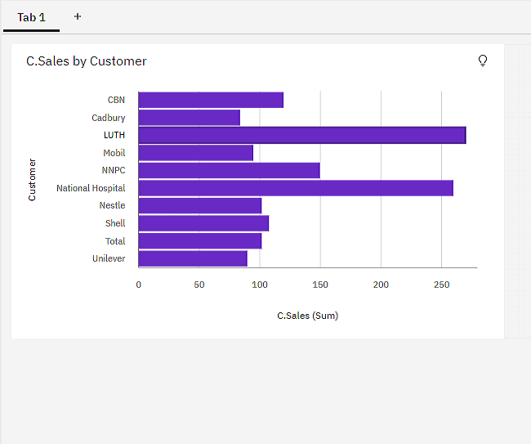

Task 2:Sales By Location

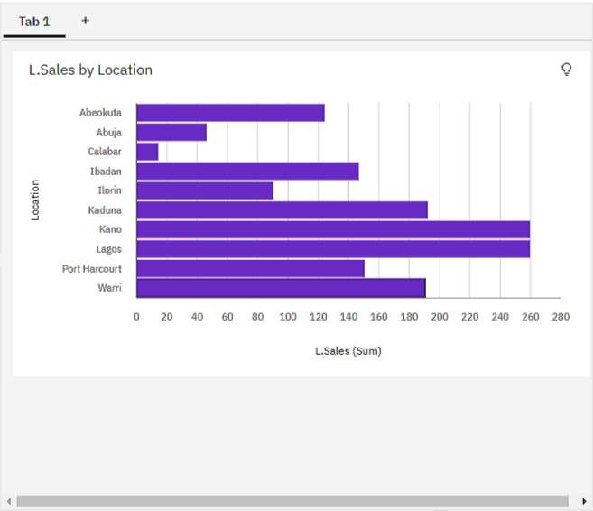

Task 3:Sales By Sales Representative

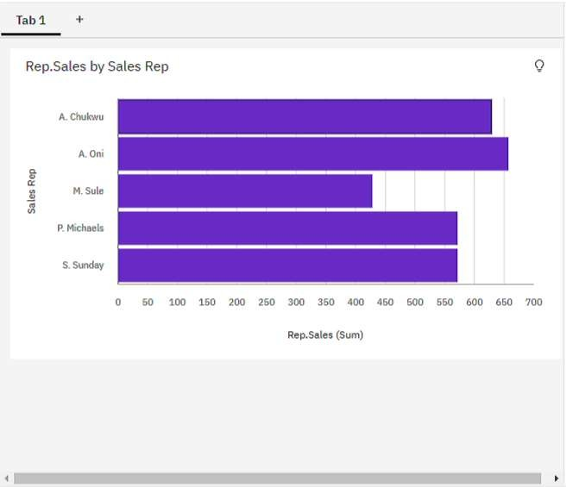

Task 4: Received Inventory From Supplier

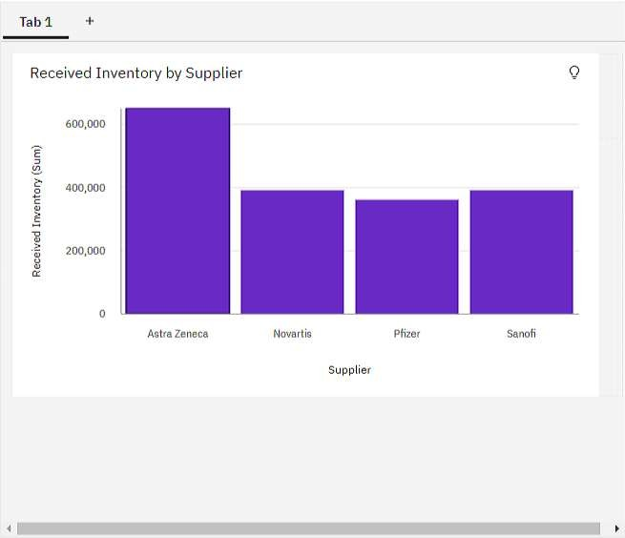

Task 5: Inventory Stock for Warehouse Locations

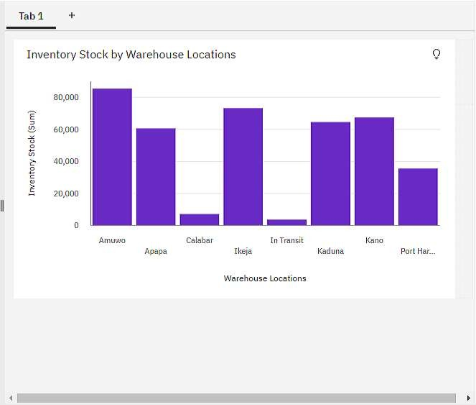

Task 6: Sales Trend

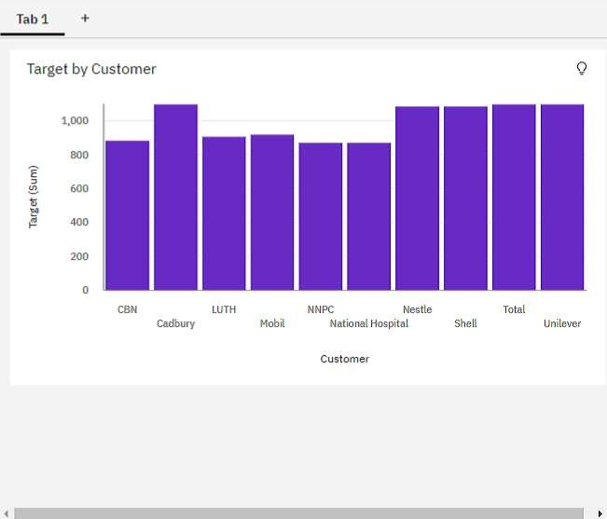

Task 7:Monthly Sales

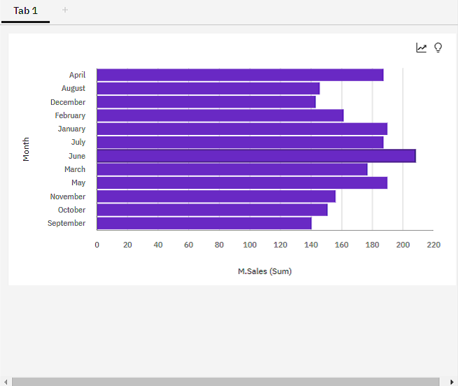

Task 8: Actual by Month

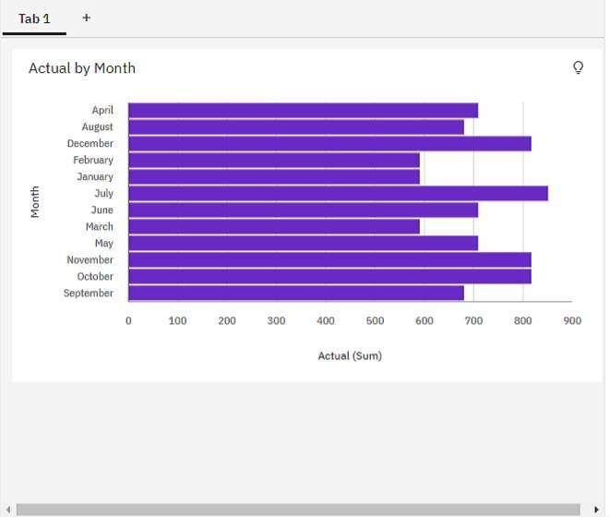

2) Received Inventory by Month

